**WEB DEVELOPMENT W/ .NET**

(By Vaishnavi B Dubal)

**Task 2:** Complete Exercise 2 from the Week 2 Power Point (broken project)

**Changes:**

1. CS1513 } expected

In TourRepository.cs at line 40 added a ‘}’ bracket.

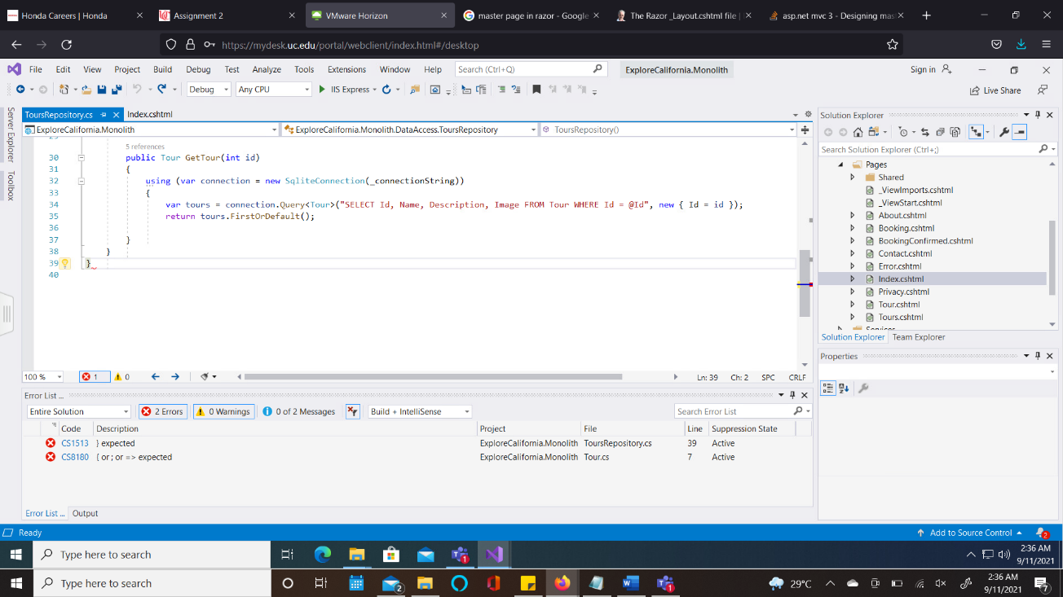

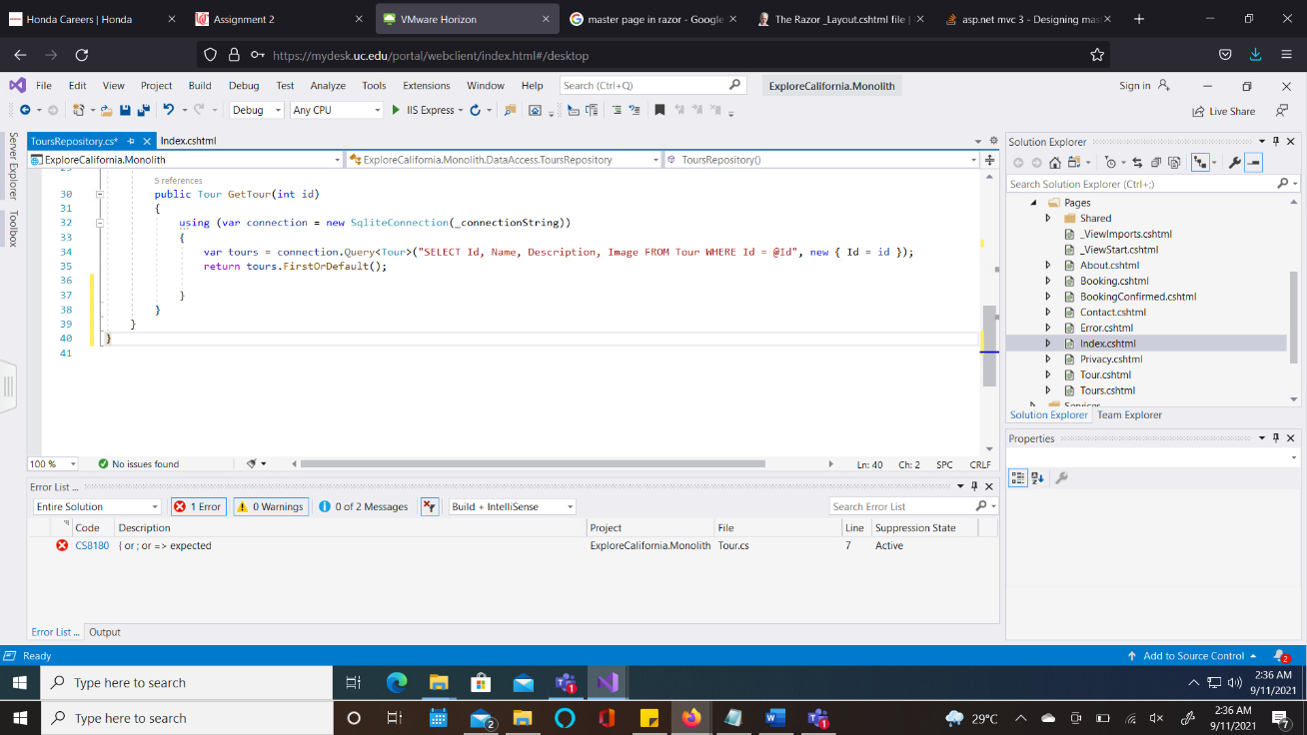

1. CS8180 { or ; or => expected

In Tour.cs , at line 7 added a ‘;’ between ‘set’ and ‘}’.

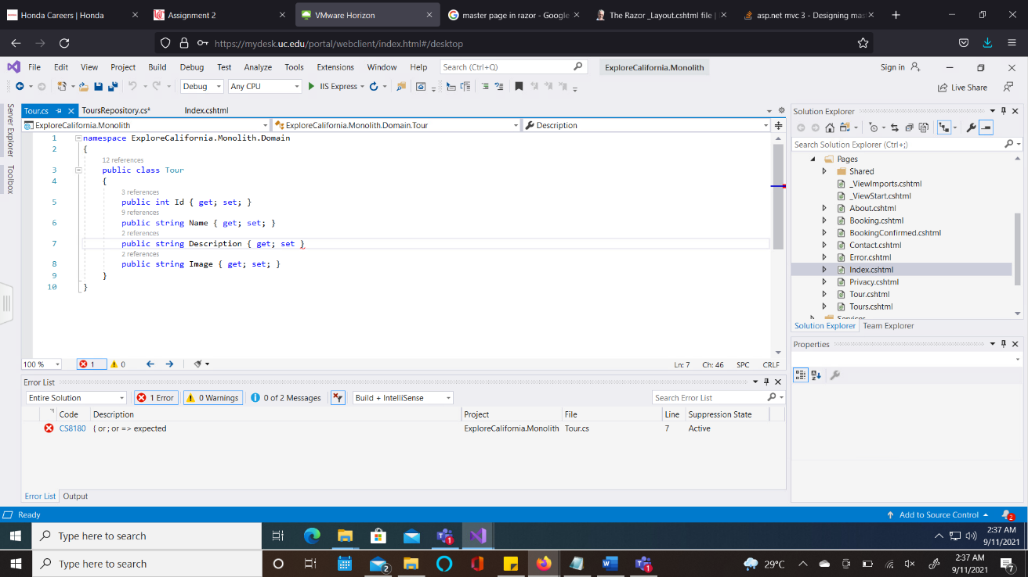

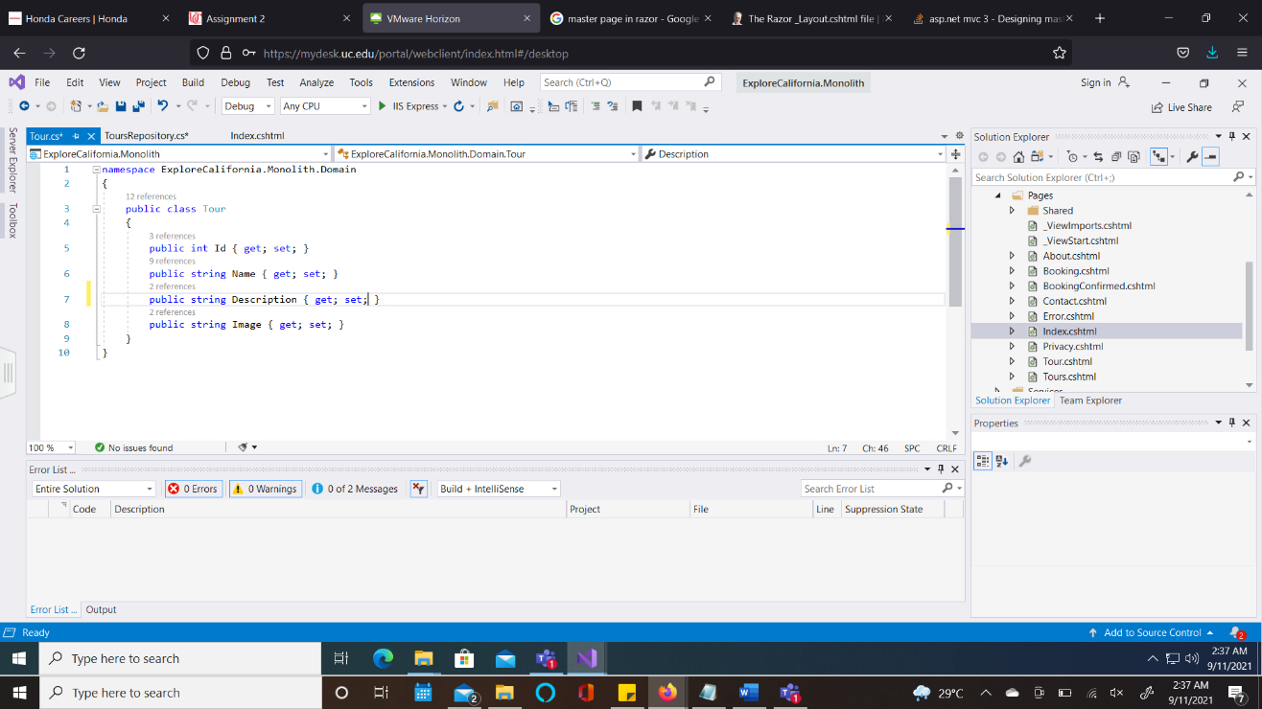

1. CS5001 Program does not contain a static ‘Main’ method suitable for an entry point

In the Program.cs file, at line 14, modified the ‘Maiin’ to ‘Main’.

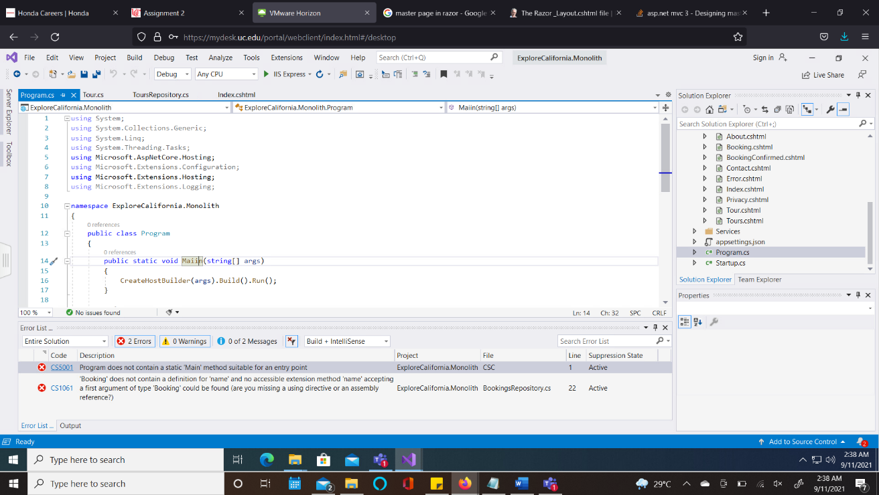

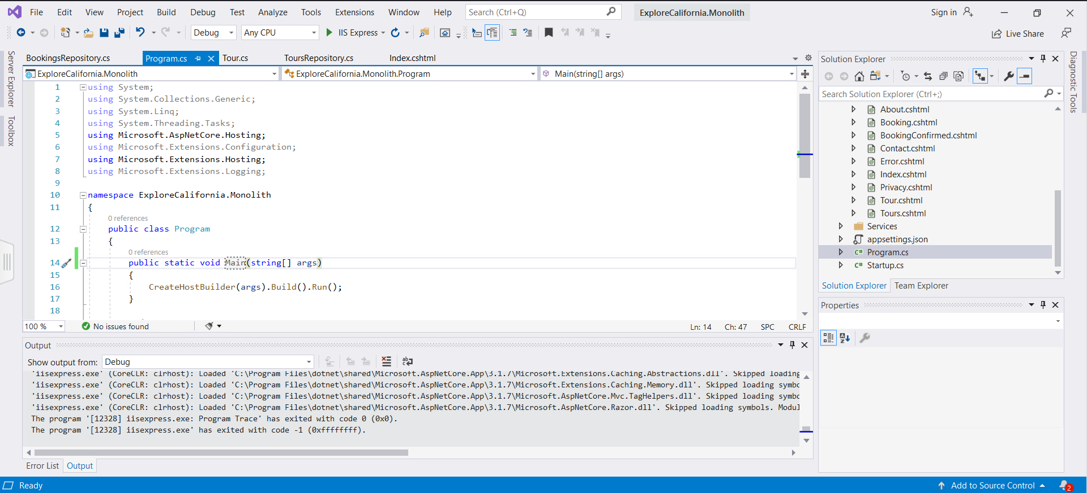

1. CS1061 ‘Booking’ does not contain a definition for ‘name’ and no accessible extension method ‘name’ accepting a first argument of type ‘Booking’ could be found (are you missing a using directive or an assembly reference? )

In BookingsRepository.cs, at line no. 22, the attribute ‘Name = booking.name’ was replaced with case sensitive value ‘Name = booking.Name’.

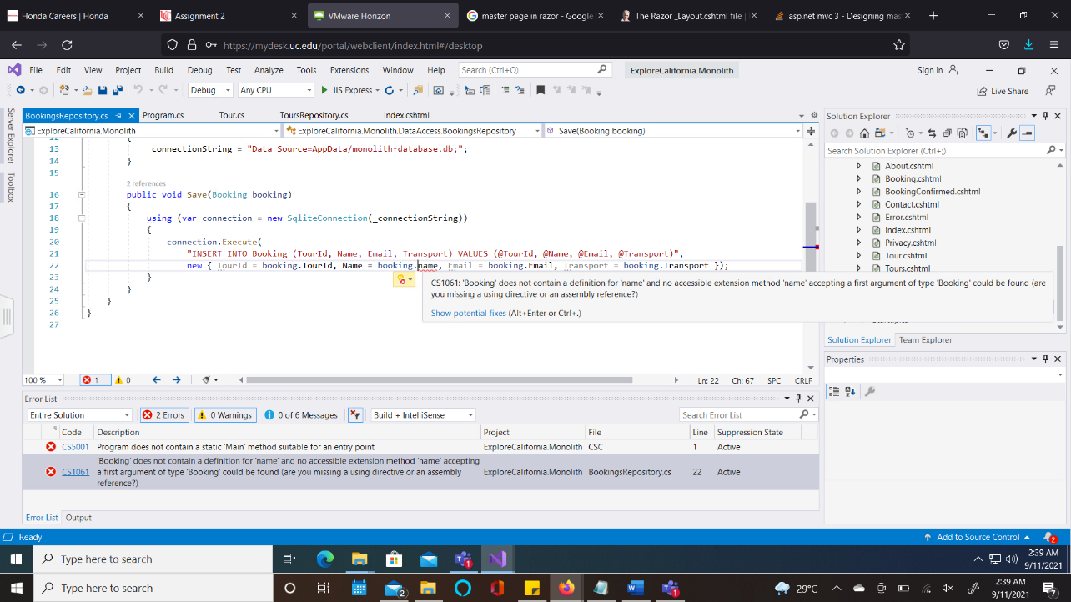

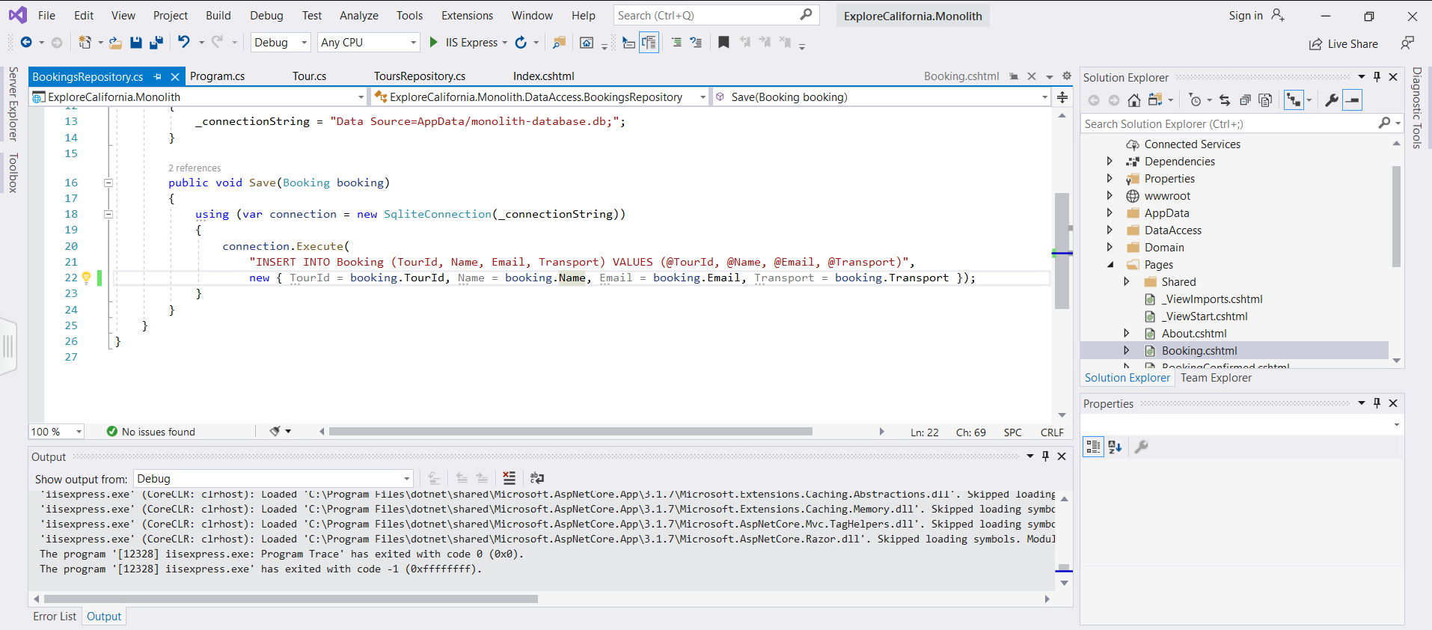

1. In ‘Index.cshtml’ file, the code from line 8 to 21 was code. After uncommenting, the browser displays the webpage.

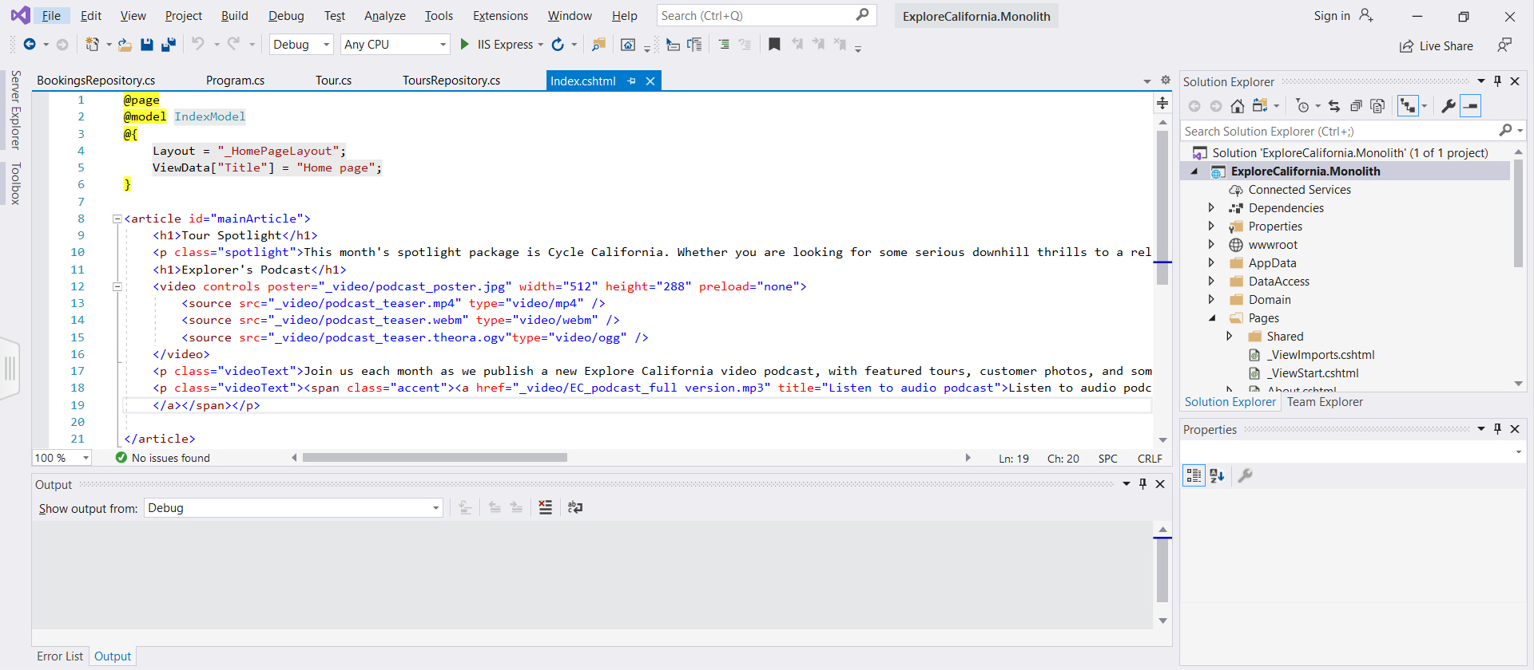

**Output:**

